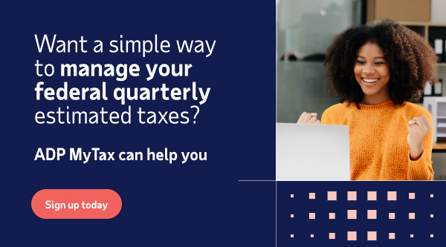

Dear [Client Name],

As your trusted CPA, I understand the importance of tax compliance and the critical role it plays in your financial well being. That’s why I’m excited to tell you about ADP MyTax, a new solution aimed at simplifying and enhancing the quarterly estimated tax experience.

Key Benefits:
It lets you pay your {tax year} federal taxes owed in the amount of [$insert amount] gradually over the year instead of one lump sum payment - at no cost! You can set aside a portion of your income based on a schedule that what works best for you. Plus, they will automatically send it to the IRS on your behalf with a confirmation receipt.

I encourage you to sign up for ADP MyTax today to avoid penalties and interest and ensure a more manageable experience.

Signed,
CPA

